**IMPLEMENTATION OF MARKERLESS AUGMENTED REALITY**

**3D PRESENTATION FOR LEARNING VIRUS ON**

**BIOLOGY LANGUAGE EYES**

**Juni Aldo Syahputra1) , Rini Sovia, S.Kom, M.Kom2) , Randy Permana, S.Kom, M.Kom3)**

Informatics Engineering, West Sumatera,

Universitas Putra Indonesia "YPTK" Padang

1. E-Mail : juni.aldo@yahoo.co.id
2. E-Mail : rini_sovia@ymail.com
3. E-Mail : randydoank17@gmail.com

**ABSTRACT**

Utilization of augmented reality technology as a virus lesson medium aims for helps students understand the forms and structure of the virus in humans and gives different experiences. In this study, we discussed a markerless method for students to be able to see directly when compared to the marker method. Markerless based virus learning augmented reality displays 3D objects of virus forms and structures for mobile devices operating system android. From the test results of the device, the application can run with a minimum android device version 4.1. From the test results students feel eager to learn the virus with the media learning application Markerless AR virus ini.Peningkat value of understanding of the virus in students.

.

Keywords: Augmented Reality, Markerless, Media Learning, Virus, Unity, Android.

# I. Introduction

Currently the learning method used in the delivery of virus material isusing the media book. while the material about this virus is very difficult to watch in daily life without the use of electron microscopy devices because of the size of the virus which is small. In the delivery of material from books, and whiteboards only show 2D visuals that make the material less interesting It is hoped this as one of the alternative learning methods that can increase the interest of students to receive the subject matter.

# II. LITERATURE REVIEW

## 2.1 Definition of Augmented Reality

Augmented Reality as a merger of real objects (real) and virtual real-time environment, runs interactively in real-time, and there is integration the relationship between objects in three dimensions, the virtual objects that are integrated in the world real [1]

## 2.2 The Markerless Definition

Rizki (2012), one of the methods of Augmented Reality is using the method markerless augmented reality, with this method the user does not need to use a marker (marker) to display the digital elements so that more efficient, practical, interesting and used anytime and anywhere [2].

Markerless Tracking techniques include the following [3]:

Application Journal Markerless Augmented Reality Virus Learning

1. Face Tracking: using the algorithms they develop, the computer will recognize the human face by recognizing the position of the eyes, the nose, and the human mouth by ignoring the surrounding objects.
2. 3D Object Tracking: 3D object technique that can recognize all forms of existing objects nearby, such as cars, desks, televisions and others.
3. Motion Tracking: in this technique the computer can capture movement in real time.
4. GPS Based Tracking: This technique is directed at smarphone, because of GPS technology and compass embedded in the smartphone. With the implementation of augmented reality features GPS can be used as a determinant of the location you want to go.

## 2.3 Three Dimensional Modeling

Nalwan (1997) in research Setiawan, Arif., Tambunan, Toufan Diansyah., & Hendriyanto, Robbi, (2016) about Android Augmented Reality To Show Catalogs Furniture Demonstration (3D) Based on Object Marker suggests that modeling is to form objects or objects by making and designing the object so it looks like [4]. There are several aspects that must be considered when building the object model to be made, all of which contribute to final acyl quality. These include methods for obtaining or creating data that describe objects, the purpose of the model, level of complexity, cost calculation, conformity and convenience, and ease of manipulation model [4].

## 2.4 Blender Hendi Hendratman (2015)

Blender is open source software (open source) computer graphics used to create animated movies, visual effects, 3D printing interactivity and video games with several features including 3D modeling, texturing, bitmap image editor, digital sculping and other features developed by neogeo [5].

## 2.5 Unity

Rickman Roedvan (2014) Unity is game maker software various platforms like unity Web Windows, Mac, Android, iOS, Xbox, Playsation 3 and wii. Unity 3D software can be used for free, but there are some features that can only be used if paying for its paid license [5].

# III. RESEARCH METHODOLOGY

Research method is reference and step which applied to a research to achieve research objectives. The research method has a work activity plan systematic and regular so that the results obtained in accordance with the expected. One of an important element of the research method is the existence of methods applied for solving research problems. The research begins with observation, observing the data who researched, conducted interviews with related parties, collected all materials obtained from journals on the internet as well as books.

# IV. ANALYSIS AND DESIGNING

## 4.1 Analysis

### 4.1.1 Problem Analysis

Problem analysis is the stage of activity in gathering information about problems that have been there before that can be used as a reference for the construction of applications augmented reality learning virus. Analyze existing problems ie the media of the process learning viruses still use book media that visualizes 2D virus objects and the use of ordinary microscope means can not see the object of the virus compared with an electron microscope, so it takes augmented reality learning application of the virus to visualize 3D virus objects to let students know the 3D forms of virus objects.

### 4.1.2 Data Analysis

Data analysis is required in order to use this augmented reality application clear picture. The data source used as a guide is the Encyclopedia Book Of Virology, and Family Album Of Viruses from the Institute of Virology University Zurich, Switzerland.

### 4.1.3 Process Analysis

Sources of data that have been obtained then taken to collect what data course that will be used. The data that has been selected then create a 3D visualization of the virus object for use in augmented reality learning applications of viruses. The design of this application using a blender to design virus and unity objects.

### 4.1.4 System Analysis

The flow of the program to be built can be seen in the following figure:

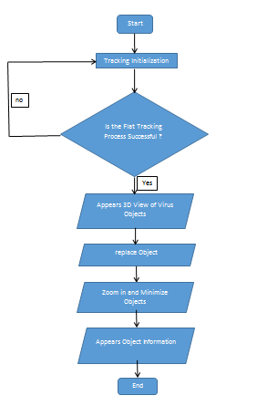

Figure 4.1 Program Flow

## 4.2 Design

### 4.2.1 Model Design

In the analysis of problem solving of application of Augmented Reality as media the introduction of existing objects is done by modeling the problem in the form UML diagrams to make it easier to move the concept of a designed system into the form of the program. Where design is described in the form of diagrams the following:

A. Use Case Diagram

Use case diagram describes the relationships that occur between actors with activities contained in the system. Actors are system users. While the system is the application of augmented reality learning virus. Use case diagram application augmented reality learning virus can be seen in the picture 4.2

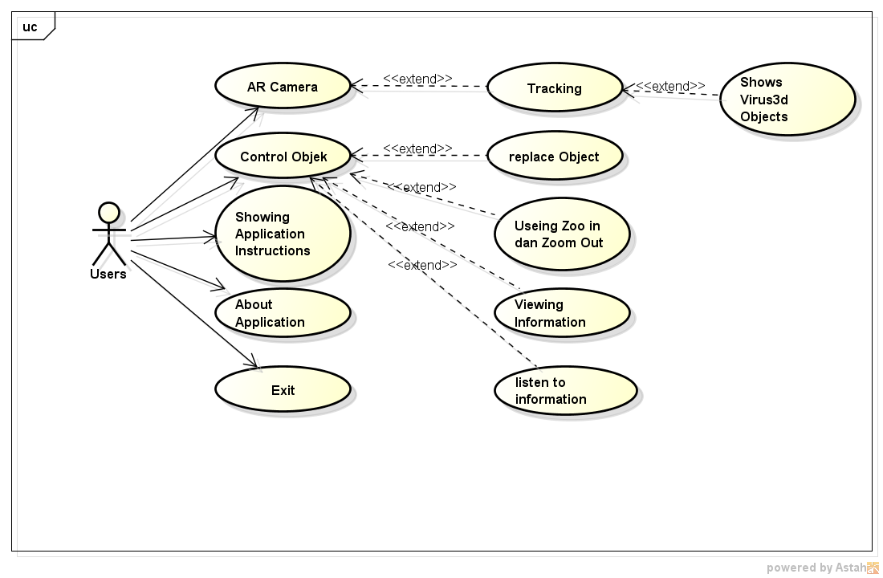

Figure 4.2 Use Case Diagram

B. Class Diagram

Class diagrams are the core of object-oriented development and design. Class diagram describes the relationship between the object and the system structure. Class diagrams of the augmented reality learning application system of the virus can be seen on Figure 4.6 below:

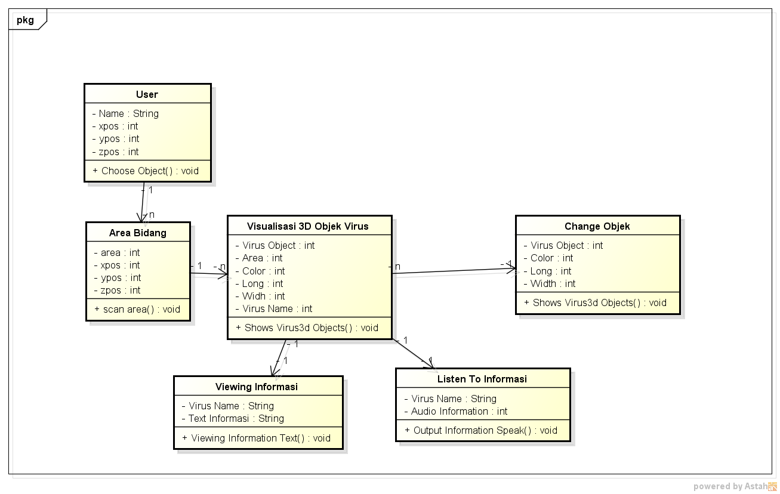

C. Activity Diagram

Activity Diagram modeling the flow of activities that occur in the use case. As for activity diagrams from the translation of each use case diagram can be explained on the activity diagram below.

a. Activity Diagram Using AR Camera

Activity diagram using AR camera describes the flow of actor work run the AR application for a flat field tracking highlighted by the AR camera. Activity diagram using AR Camera can be seen in Figure 4.3 below:

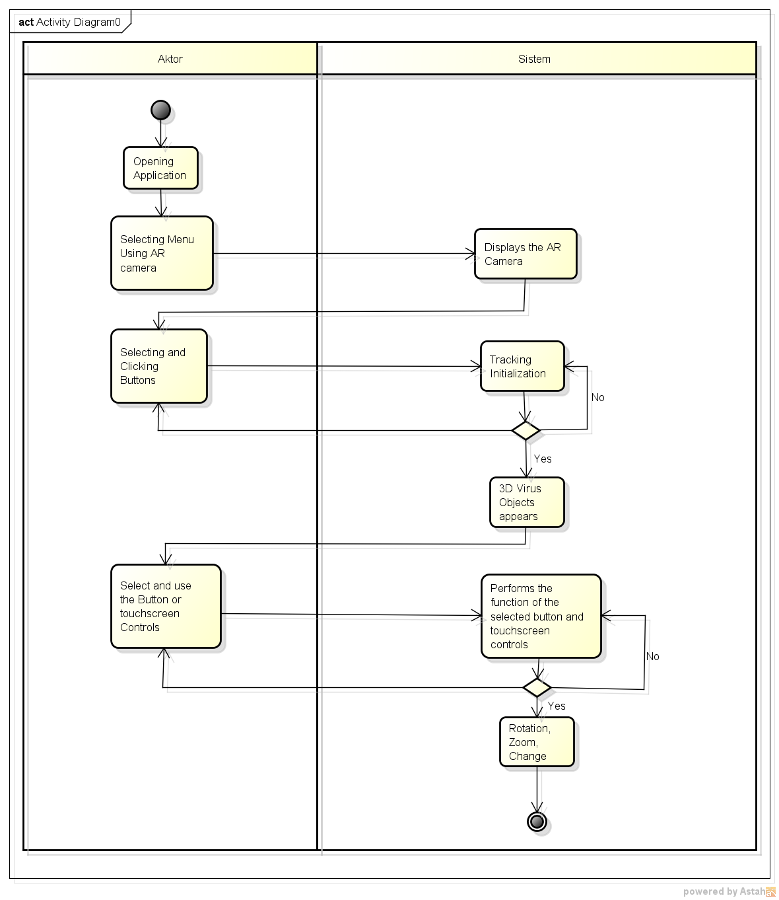

Figure 4.6 Activity Diagram Displays 3D Objects

D. Sequence Diagram

Sequence diagrams describe the interaction between objects. Interaction between objects in the form sending data between objects in a time sequence. The sequence diagram is augmented app reality learning virus is as follows:

1. Sequence Diagram Displays 3D Objects

Sequence diagram from displaying 3D objects can be seen in the following figure:

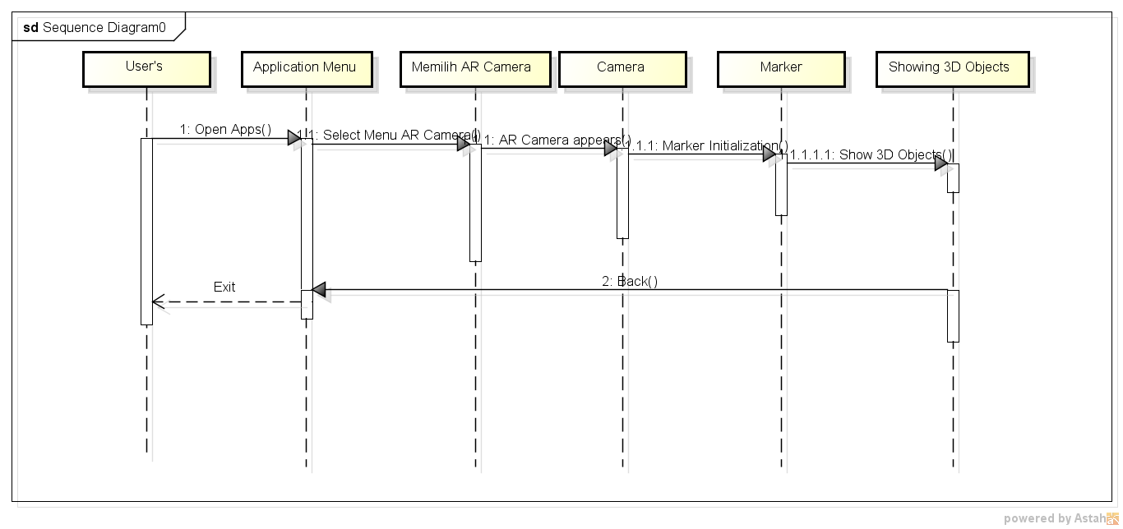

Figure 4.7 Sequence Diagram Displays 3D Objects

In the above sequence diagram the user directs the AR camera to the flat field. System will access the image located in the device application, after which it will bring up the object 3D, and information.

1. Sequence Diagram Instructions for Use and About Applications Sequence diagrams of the usage instructions and about the application can be viewed on the following picture:

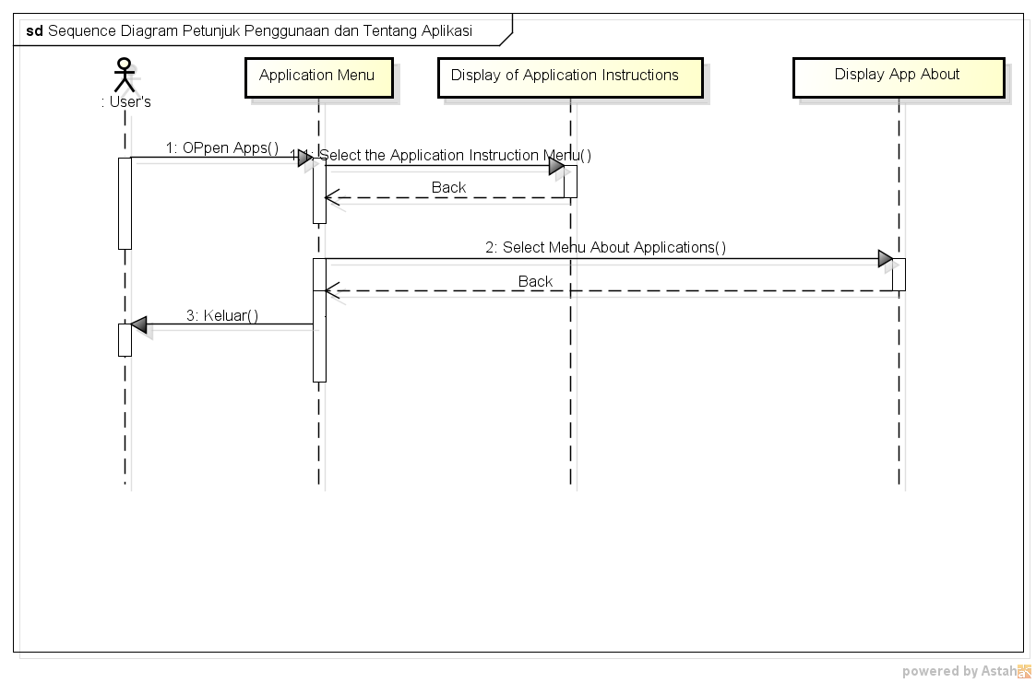

Figure 4.8 Sequence Diagram Instructions for Use and About Applications

1. Collaboration Diagram Instructions for Use and About Applications

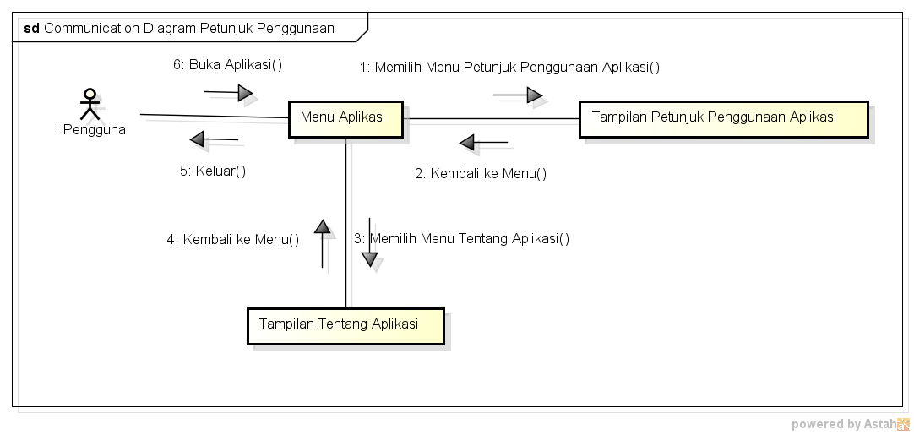

Figure 4.11 Collaboration Diagram Instructions for Use and About Applications

1. State chart diagram

Describes the status changes that occur when the system is run. Changes are occurs on an object will be described by this diagram in the form of directed graph statechart diagram augmented reality application learning virus is as follows:

1. StateChart Diagram Displays Objects

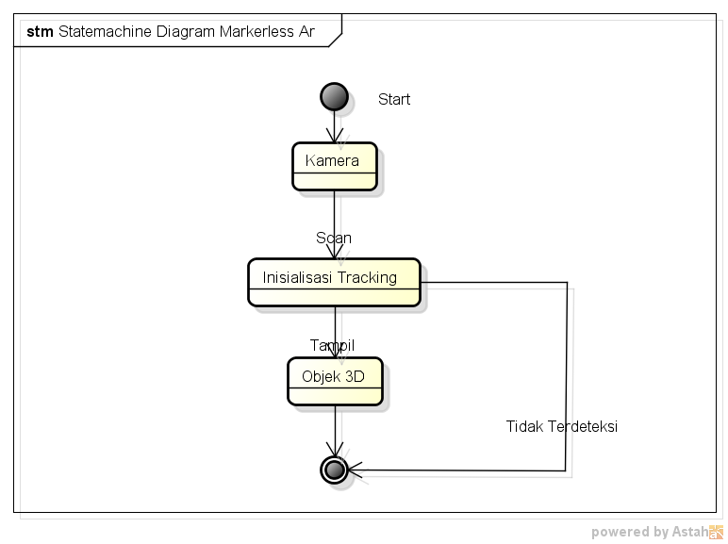

Figure 4.12 State Chart Diagram Displays Objects

1. StateChart Object Control Diagram

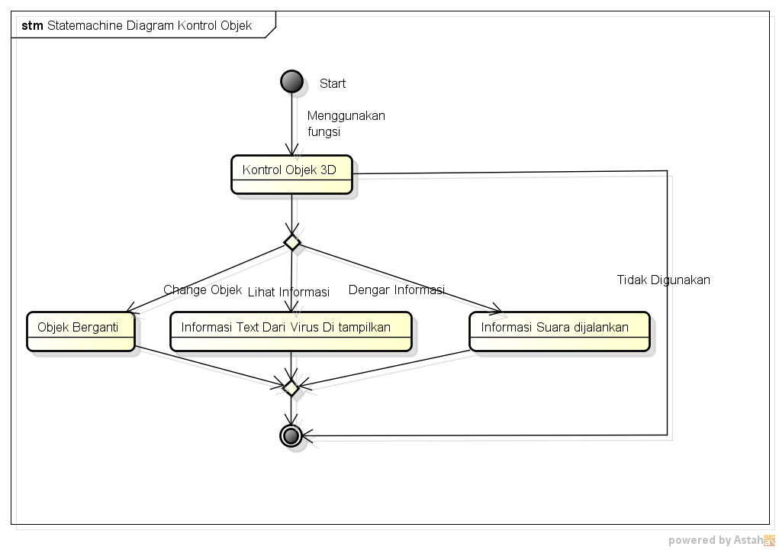

Figure 4.13 State Chart Object Control Diagram

1. Deployment Diagram

Deployment diagrams describe in full how the components of deployment diagram in the system infrastructure, where the component will be located. As for deployment diagram can be seen in the following figure 4.13

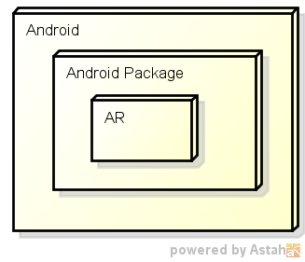

Figure 4.14 Deployment Application AR Diagram

# 4.3 Interface Design

1. Splashscreen Interface Design

The splashscreen menu is displayed when the app is first run with time appears 5 seconds. This menu shows the logo and application name.

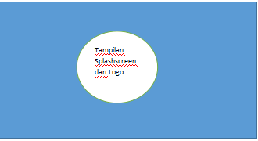

Figure 4.15 Splashscreen and Loading Pages

1. Interface Design Main Menu

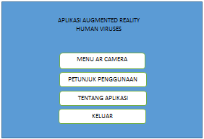

Figure 4.16 Main Page

1. Interface Design AR Camera Page

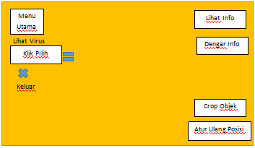

Figure 4.17 Page Ar Camera

# V. IMPLEMENTATION AND TESTING

## 5.1 Implementation Phase

Implementation is an action taken to find out what if applications that have been built can be implemented into a system, whether the application this is able to provide good benefits for the user. Implementation is also done for know the system limits required in running this application.

### 5.1.2 Application Testing

At this stage the authors to test the applications that have been designed and ensure the application works in accordance with the planned.

### 5.1.3 Interface Testing

In testing this interface, see whether the system interface is eligible as userfriendly interface for users later on. Interface testing is done in order android based system easy to use by the user later.

1. Display Main Menu

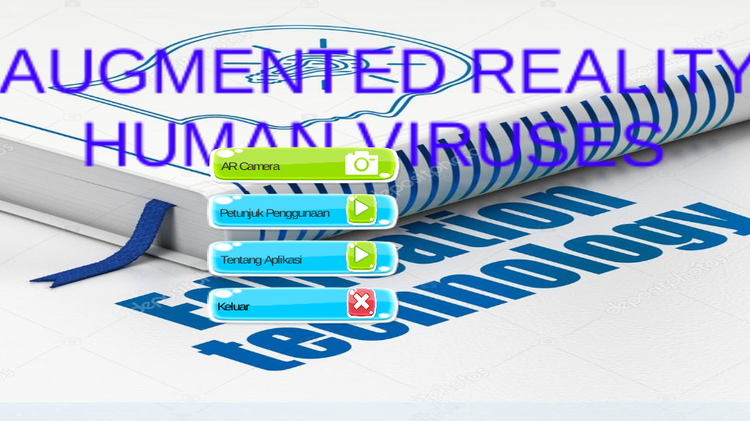

Figure 5.30 Display Android Home Page

1. Display AR Camera on Android Smartphone

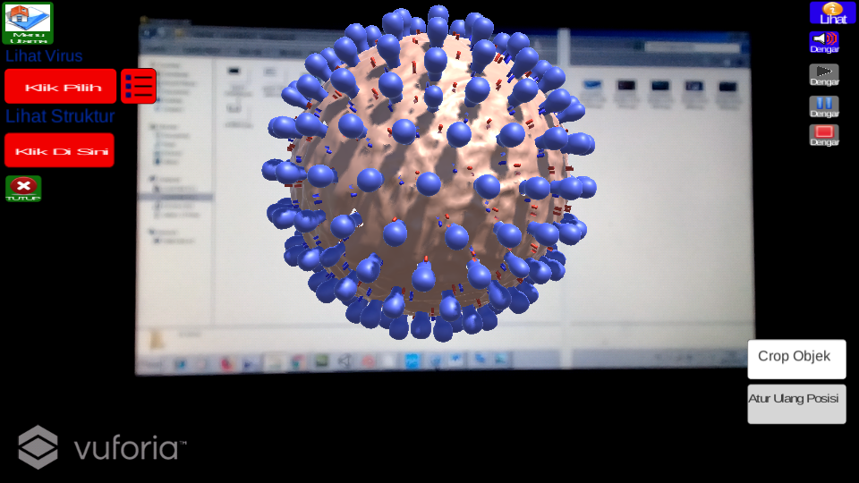

Figure 5.21 Display AR Camera on Android Smartphone

1. AR Camera Display For Info

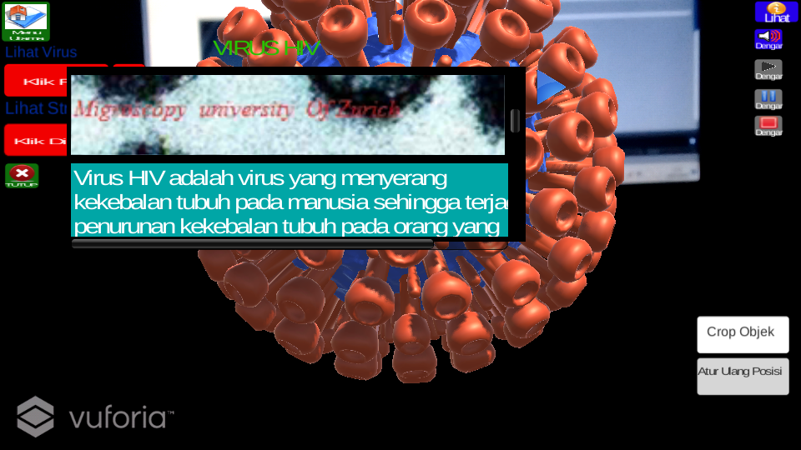

Figure 5.23 Display AR Camera At Info Button

1. Display AR Camera Display On Crop Object Button

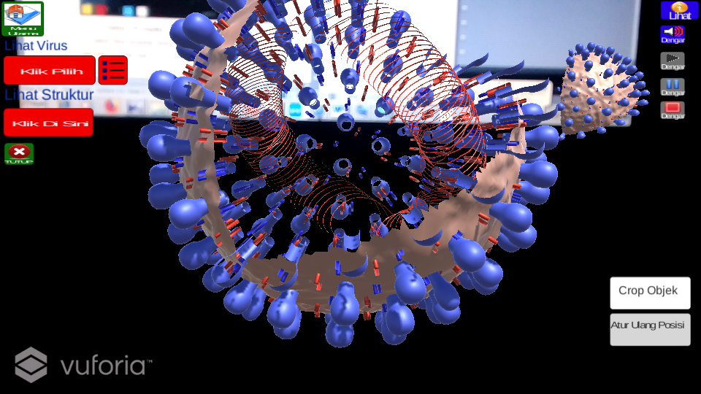

Figure 5.24 Display AR Camera On Crop Object Button

# VI. COVER

## 6.1 Conclusions

From the description of the problem above, can be drawn some conclusions, namely:

1. By using augmented reality app, it can be used as new media in visualizing virus objects other than the 2D form found in textbooks biology.
2. With the application of augmented reality, can provide more knowledge to students about the virus thereby increasing the knowledge of students to get to know forms, structures, and ways of spreading them in humans and increased knowledge of students to recognize forms, structures, and ways the spread of the virus found in humans will also bring a positive impact for students to know, prevent and overcome the transmission.
3. With the application of augmented reality can show the forms and structure of virus so that students can understand the various viruses and structures.
4. With the application of augmented reality can be used and used well, students can interact with three-dimensional objects (3D) by rotating, enlarging, zoom out, and move objects, and can display virus information and listen to information when three-dimensional objects (3D) viruses appear.

# 6.2 Suggestions

From augmented reality apps that have been designed and built, then the app augmented reality can only run in accordance with its limitations, as follows:

1. This augmented reality app can only run on android version, preferably   
   multiplatform so that more are wearing.
2. Augmented Reality application can only be run on android device version 4.1 Jelly Bean up.
3. This Augmented Reality App only displays the 3D object of the virus that has been selected and designed by the author.
4. This Augmented Reality App only displays the forms and structure of the object 3D virus that has been provided by the author.

# BIBLIOGRAPHY

[1] Ardhianto, Eka., Hadi Kurniawati., & Winarno, Edy. 2012. Augmented Reality Object 3 Dimensions with Artoolkit and Blender Devices. Journal of Information Technology DYNAMICS Vol. 17 No. 2. ISSN: 0854-9524

[2] Saputro, Rujianto Eko & Saputra, Dhanar Intan Surya. 2014. Media Development Learning to Know Human Digestive Organs Using Augmented Technology Reality. Journal of Buana Informatics Vol. 6 No. 2.

[3] Rahman, Abdur., Ernawati., & Coestera, Funny Farady. 2014. Design Bnagun Applications Information University of Bengkulu As A Guide Introduction to Using Campus Anroid Augmented Reality Based Markerless Method. Recursive Journal Vol. 2 No. 2. ISSN: 2303-0755.

[4] Falahudin, Iwan.2014. Utilization Media in Learning. Journal of Lingkar Widyaiswara Issue 1 No.1. ISSN: 2355- 4188

[5] Setiawan, Arif., Tambunan, Toufan Diansyah., & Hendriyanto, Robbi. 2016. Android Augmented Reality To Show Furniture Catalog In Three Demands (3D) Based on the Marker Object. Journal of e-Proceeding of Applied Science Vol. 2 No. 1.